

Smart Farming System
Object Oriented Programming

Submitted By
Name Shayan Ali
Roll No b-29895
Section A

Submitted To
Rabia Tabasam
Muhammad Umair Bin Yaseen

Submission Date: DD-01-2026

Department of Computer Science

University of South Asia
TABLE OF CONTENTS
ABSTRACT ..............................................................................……..4
1. INTRODUCTION ...............................................................5
1.1 Background of the Study ....................................................5
1.2 Problem Statement ..............................................................5
1.3 Objectives ................................................................................5
1.4 Scope .........................................................................................5
1.5 Significance ............................................................................5
2. LITERATURE REVIEW .................................................5
2.1 Review of Related Work ....................................................5
2.2 Comparative Analysis ........................................................5
2.3 Research Gaps .....................................................................6
3. REQUIREMENTS ANALYSIS ........................................6
3.1 Functional Requirements ..................................................6
3.2 Non-Functional Requirements ........................................6
3.3 Constraints ..............................................................................6
4. SYSTEM DESIGN & METHODOLOGY ........................6
4.1 Proposed System ................................................................6
4.2 Tools and Technologies ...................................................6
4.3 Flow of Execution ..............................................................6
5. IMPLEMENTATION ......................................................7
5.1 Module Description ...........................................................7
5.2 Implementation of OOP Principles ..............................7
5.3 Challenges Faced ...............................................................
6. TESTING & RESULTS ...................................................8
6.1 Testing Strategy ..................................................................8
6.2 Test Cases ...............................................................................8
6.3 Results & Analysis ..............................................................10
7. CONCLUSION & FUTURE WORK ..............................11
7.1 Conclusion .............................................................................11
7.2 Limitations ............................................................................11
7.3 Future Enhancements .....................................................11
8. REFERENCES / BIBLIOGRAPHY .............................11
9. APPENDICES ...............................................................12
9.1 User Data Structure ....................................................12
9.2 Validation Function .................................................... 12
9.3 Analysis Module .......................................................... 12
9.4 Temperature Module ................................................12
9.5 Moisture and Hydration ............................................13
9.6 Salinity Analysis .......................................................... 13
9.7 Fertilizer Knowledge .................................................. 13
9.8 Overall Analysis Logic ............................................... 13
9.9 Message Module ......................................................... 14
9.10 Front Dashboard ...................................................... 14
9.11 User Output .............................................................. 14
9.12 Soil Output .................................................................15
9.13 Temperature Output ..............................................15
9.14 Moisture and Hydration Output .......................15
9.15 Recommendation and Final Analysis .............16

ABSTRACT
The agricultural sector in Pakistan serves as the backbone of the national economy, yet it faces critical challenges due to traditional soil mismanagement and increasingly unpredictable environmental conditions. The primary objective of this project, titled the Smart Farming System, is to bridge the technological gap between complex agricultural soil science and practical, everyday farming. By leveraging the power of data-driven decision-making, the system aims to provide farmers with a reliable tool to mitigate risks associated with soil degradation and climate volatility.The methodology for this project involved a comprehensive requirement analysis of common physiological plant stresses, such as anoxia (root suffocation due to waterlogging) and osmotic shock (cellular dehydration caused by high salinity). Following this research phase, a modular software architecture was implemented using the C++ programming language within the Dev-C++ Integrated Development Environment (IDE). The system utilizes core Object-Oriented Programming (OOP) principles, including inheritance, encapsulation, and polymorphism, to manage a dynamic database of crop categories and user profiles.Central to the application is a custom-built "Weighted Stress Algorithm." This algorithm processes real-time inputs of soil type (Sandy, Clay, Loamy), ambient temperature, moisture percentage, and salinity levels to calculate an estimated yield potential. Furthermore, the system incorporates an educational "Knowledge Base" that informs the user of the scientific reasoning behind each recommendation.Results from the testing phase indicate that the system successfully identifies high-risk environmental conditions, such as high salinity concentrations or extreme thermal stress. By providing actionable advice—ranging from specific NPK fertilizer ratios to irrigation adjustments—the system empowers farmers to prevent crop failure and optimize agricultural output. This project demonstrates how simple computational logic can be applied to solve complex, real-world problems in the Pakistani agricultural landscape.

1.INTRODUCTION
1.1 Background of the Study
Most local farmers rely on traditional experience, which often does not account for microscopic soil changes such as salinity levels or precise moisture percentages. This lack of scientific insight can lead to inefficient farming practices and reduced productivity.
1.2 Problem Statement
The absence of accessible, data-driven agricultural tools results in improper fertilizer usage and poor irrigation timing. These issues negatively affect crop yield while causing unnecessary wastage of water and nutrients.
1.3 Objectives
The primary objective of this project is to develop a console-based system that educates users while providing scientific soil and crop analysis. The system supports crops from three categories: Fruits, Vegetables, and Cereals.
1.4 Scope
The system is limited to three major soil types: Sandy, Clay, and Loamy. Based on user inputs, it generates a comprehensive five-point analysis report to guide effective farming decisions.
1.5 Significance
This project empowers farmers by converting raw environmental data into a structured Farming Plan. It contributes to improved crop productivity, enhanced resource efficiency, and greater food security.

2. LITERATURE REVIEW
2.1 Review of Related Work
Existing agricultural decision-support systems often depend on expensive hardware sensors and IoT devices, making them inaccessible to small-scale and local farmers. In contrast, this project proposes a software-based model that offers a low-cost and easily deployable entry point into data-driven farming.
2.2 Comparative Analysis
Unlike conventional systems that rely on static lookup tables, the proposed system utilizes object-oriented programming concepts such as inheritance, along with a dynamic yield-scoring algorithm. This approach enables personalized and adaptive recommendations based on user inputs.
2.3 Research Gaps
Most locally available agricultural software focuses solely on output recommendations without explaining the underlying scientific principles. The proposed system addresses this gap by integrating a Knowledge Base that educates users on concepts such as Osmosis and Anoxia before collecting input, thereby improving understanding and informed decision-making.
3. REQUIREMENTS ANALYSIS
3.1 Functional Requirements
User registration for new users and login for existing users
Validation of numeric inputs such as age, temperature, and moisture level
Validation of string-based inputs including soil type and salinity level
Automated calculation of crop yield percentage based on user inputs
3.2 Non-Functional Requirements
Reliability: The system must handle invalid or incorrect inputs without crashing
Usability: The interface should provide clear headings and easily scannable information suitable for farmers
3.3 Constraints
The system is developed using the Dev-C++ IDE and relies solely on standard C++ libraries. All interactions are console-based, with no graphical user interface support.

4. SYSTEM DESIGN & METHODOLOGY
4.1 Proposed System
The proposed system is a modular, console-based C++ application designed using object-oriented principles. It utilizes Classes for crop categorization and Structures for efficient user data management, ensuring code modularity, reusability, and clarity.
4.2 Tools and Technologies
Dev-C++ IDE
Programming Language: C++ (C++98 / C++11)
Standard Header Files: <iostream>, <vector>, <string>
4.3 Flow of Execution
The system initializes by loading five pre-seeded users into the database vector and displays the project introduction.
The user selects a primary role from the main menu: Admin, User/Farmer, or Exit.
The Admin path displays an authorized dashboard containing the complete list of registered user credentials.
The User/Farmer path branches into two options: New User (Sign Up) or Existing User (Sign In).
After successful authentication, the system presents a Knowledge Base explaining soil science concepts such as osmosis and thermal biology.
The system prompts the user to enter soil type, temperature, moisture level, and salinity while enforcing strict input validation.
The user selects a crop category, triggering object-oriented inheritance to verify the specific crop name.
The Weighted Stress Algorithm evaluates environmental inputs against predefined scientific thresholds to determine soil stress and impact.
A detailed five-point analysis report is generated, covering irrigation planning, pest risk, fertilizer recommendations, and yield potential.
The system displays a personalized advisory message and returns to the main menu for the next operation.

5. IMPLEMENTATION
5.1 Module Description
Authentication Module: Manages the vector<User> database for user registration (sign-up) and login (sign-in).
Knowledge Module: Displays educational content related to soil science and basic biological concepts to improve user understanding before data input.
Analysis Module: Acts as the core logic of the system by processing user inputs and generating scientific recommendations and yield analysis.
5.2 Implementation of OOP Principles
Encapsulation: User data and soil parameters are grouped into a User structure to protect data integrity and improve modularity.
Abstraction: Complex yield calculation formulas are hidden from the user, with only the final analytical results displayed.
Inheritance: Fruit, Vegetable, and Cereal classes are derived from a common base class Crop to promote code reusability.
Polymorphism: The confirmSelection() method is overridden to display category-specific confirmation messages based on the selected crop type.
5.3 Challenges FacedCompiler Compatibility:
Older versions of Dev-C++ do not support C++11 brace-initialization for vectors. This was resolved by manually initializing objects and assigning individual members before inserting them into the database.
Input Buffer Management: Entering non-numeric values into integer or floating-point fields caused infinite input loops. A validation function using cin.clear() and cin.ignore() was implemented to flush the input buffer and maintain stability.
Data Validation: Restricting soil type input to valid values (sandy, clay, loamy) required a while loop with conditional checks to prevent invalid data from entering the algorithm.
Case Sensitivity: Crop names are required to be entered in lowercase to prevent duplicates such as “Apple” and “apple” from being treated as different entries.
Memory Management: Managing a dynamic list of users using std::vector required careful indexing to ensure the Admin dashboard correctly displayed newly registered farmers.

6. TESTING & RESULTS
6.1 Testing Strategy
The testing of the Smart Farming System was carried out using a manual testing approach, focusing mainly on Unit Testing and Black Box Testing techniques. Since the system is developed in C++ using object-oriented programming, each major module such as user authentication, input validation, crop selection, and farming analysis was tested independently.The testing strategy aimed to:Verify correct handling of user inputsEnsure validation functions work properlCheck correctness of analysis and recommendation logiConfirm smooth system navigation for Admin and User rolesNo automated testing framework was used; instead, different input scenarios were manuallyexecuted and results were observed and compared with expected outcomes.
6.2 Test Cases
The following table shows representative test cases applied to the system:
Test Case 1: User Login (Valid Credentials)
Item | Description
Module Tested | Sign In
Input | Email: rabia@gmail.com, Password: pass123
Expected Output | Successful login message
Actual Output | Login Successful
Status | Pass
Test Case 2: User Login (Invalid Credentials)
Item | Description
Module Tested | Sign In
Input | Email: abc@gmail.com, Password: 123
Expected Output | Error message
Actual Output | Credentials not found
Status | Pass
Test Case 3: Soil Type Validation
Item | Description
Module Tested | Soil Input
Input | sandyy
Expected Output | Error message
Actual Output | Error displayed
Status | Pass
Test Case 4: Crop Name Validation
Item | Description
Module Tested | Crop Selection
Input | Tomato123
Expected Output | Validation error
Actual Output | Error displayed
Status | Pass
Test Case 5: Temperature Input Validation
Item | Description
Module Tested | Temperature Input
Input | abc
Expected Output | Numeric input error
Actual Output | Error message shown
Status | Pass
Test Case 6: Yield Calculation
Item | Description
Module Tested | Yield Estimation
Input | Sandy soil, High salinity, Temperature > 32°C
Expected Output | Reduced yield percentage
Actual Output | Yield reduced correctly
Status | Pass
6.3 Results & Analysis
The testing results indicate that the Smart Farming System functions correctly and reliably under various input conditions. All major modules passed their respective test cases successfully. Input validation mechanisms effectively prevented invalid data entry, ensuring system stability.The object-oriented structure, including inheritance (Crop, Fruit, Vegetable, Cereal) and modular functions, improved testability and code clarity. The farming analysis module correctly generated recommendations based on soil type, temperature, moisture, and salinity.Minor limitations were observed such as the absence of exception handling and automated testing tools; however, these do not affect the core functionality of the system. Overall, the system produced accurate analysis results and meaningful recommendations, meeting the project objectives

7. CONCLUSION & FUTURE WORK
7.1 Conclusion
The project successfully demonstrates that a software-based system can simplify complex agricultural science concepts for everyday users, especially local farmers.By combining scientific analysis with an educational approach, the system bridges the gap between traditional farming knowledge and data-driven decision-making.
  - Limitations
The system is entirely text-based and does not include a graphical user interface.
User data is stored temporarily during runtime and is not saved to an external permanent storage device such as a hard drive.
7.3 Future Enhancements
Integration of the fstream library to enable permanent data storage and retrieval.
Development of a graphical user interface (GUI) to improve usability and overall user experience.
Expansion of crop categories and inclusion of real-time environmental data for enhanced accuracy.
8. REFERENCES / BIBLIOGRAPHY

B. Stroustrup, The C++ Programming Language, 4th ed. Boston, MA, USA: Addison-Wesley, 2013.R. Lafore, Object-Oriented Programming in C++, 4th ed. Indianapolis, IN, USA: Sams Publishing, 2002.

S. B. Lippman, J. Lajoie, and B. E. Moo, C++ Primer, 5th ed. Boston, MA, USA: Addison-Wesley, 2012.

ISO/IEC, “Software Engineering — Software Testing Principles,” ISO/IEC 29119, 2019.

APA FORMAT

Stroustrup, B. (2013). The C++ programming language (4th ed.). Addison-Wesley.

Lafore, R. (2002). Object-oriented programming in C++ (4th ed.). Sams Publishing.

9APPENDICES
9.1User Data Structure
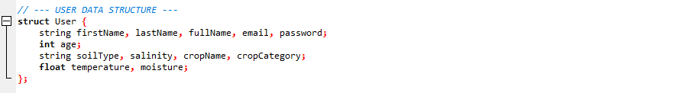
9.2Validation Function
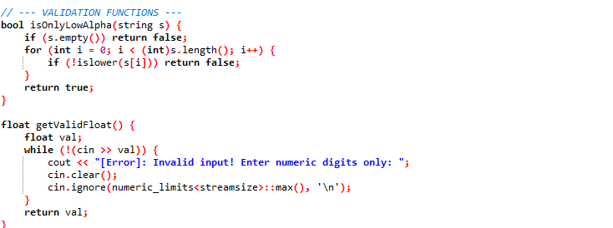
9.3Analysis Module
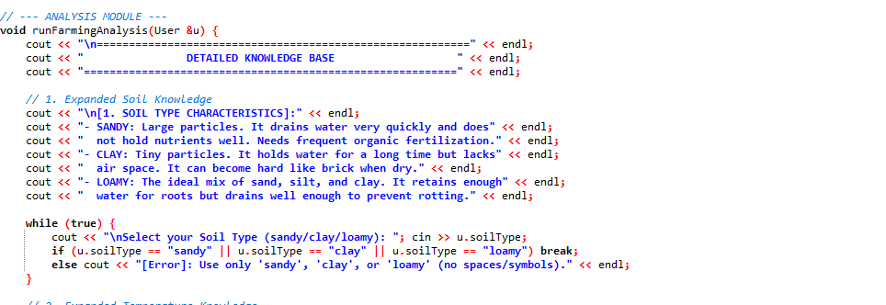
9.4Temperature 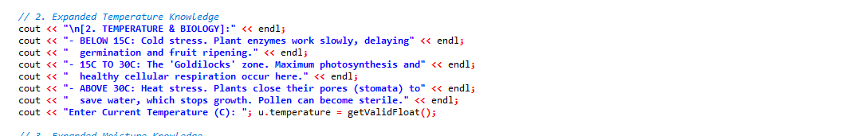

9.5Moistuness and hydration 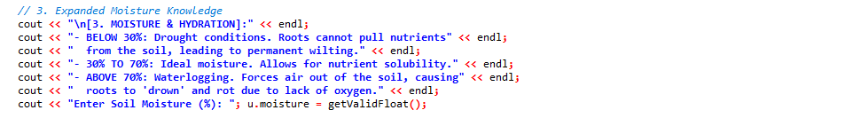
8.6 Salinity
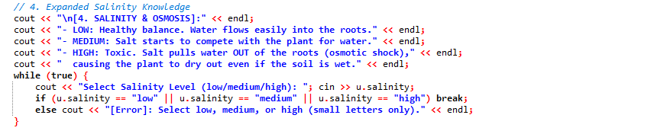
8.7 Fertilizer knowledge
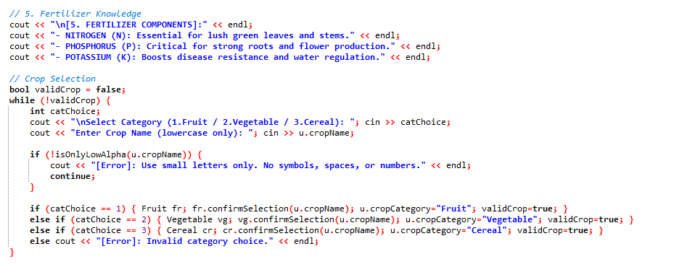
8.8 Analysis
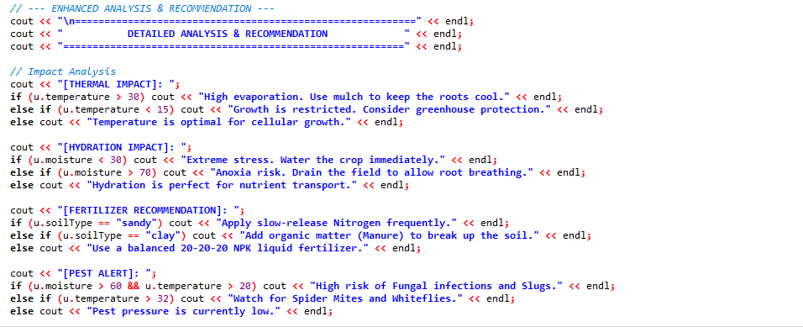
8.9 Messager
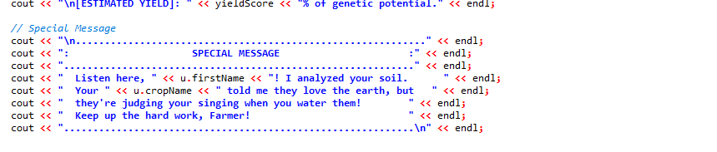8.10 Front Dashboard
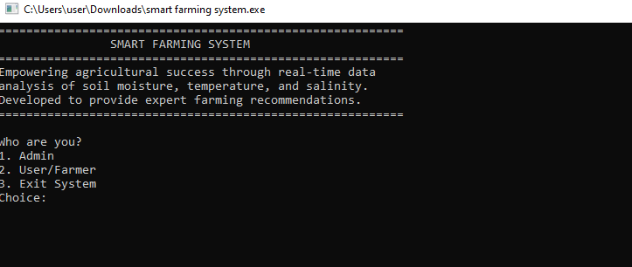
8.11 User Output
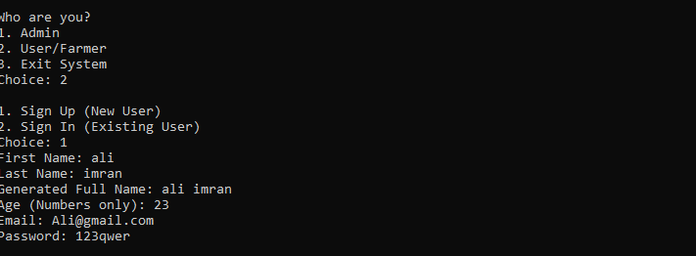

8.12 Soil Output
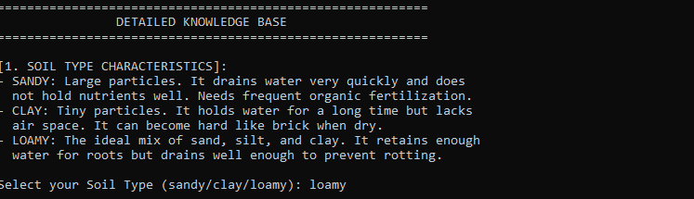
8.13 Temperature output
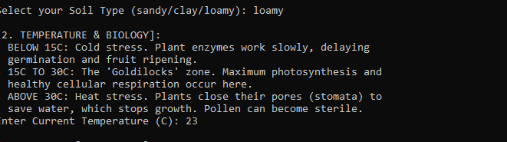
8.14 Moistness and hydration Output
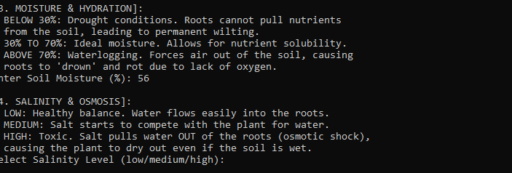

8.15 Recommendation and analysis
